Import & export data
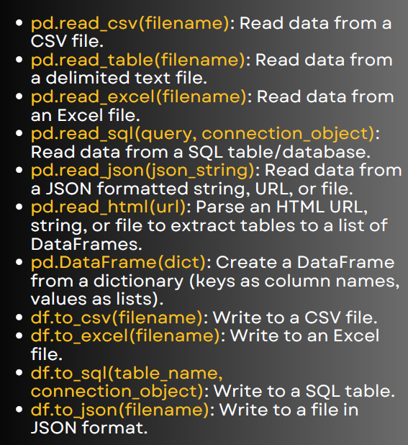

1. Read CSV
import pandas as pd
# Import data from CSV file
df = pd.read_csv("sales.csv")
print(df.head()) # Shows first 5 rows
Used when data is stored in a .csv file.

2. Read Table (Delimited File)
# Suppose data.txt contains values separated by tab (\t)
df = pd.read_table("data.txt", delimiter="\t")
print(df.head())
Useful when working with .txt files or custom delimiters.

3. Read Excel
# Requires 'openpyxl' installed
df = pd.read_excel("employees.xlsx", sheet_name="Sheet1")
print(df.head())
Used for Excel files (.xlsx, .xls).

4. Read SQL
import sqlite3
# Create connection
conn = sqlite3.connect("company.db")
# Run SQL query and load into DataFrame
df = pd.read_sql("SELECT * FROM employees", conn)
print(df.head())
conn.close()
Helps in pulling data directly from a database.

5. Read JSON
# JSON string
data = '{"name":["Amit","Sara"], "age":[25,30]}'
df = pd.read_json(data)
print(df)
Reads JSON from string, file, or URL.

6. Read HTML
url = "https://www.worldometers.info/world-population/"
dfs = pd.read_html(url)
# Extract first table
print(dfs[0].head())
Extracts tables from websites into DataFrames.

7. Create DataFrame from Dictionary
data = {
"Name": ["Ravi", "Priya", "John"],
"Age": [25, 30, 28],
"City": ["Hyderabad", "Delhi", "Mumbai"]
}
df = pd.DataFrame(data)
print(df)
Quick way to create DataFrame.

Export Examples
8. To CSV
df.to_csv("output.csv", index=False)
Saves DataFrame to CSV file.

9. To Excel
df.to_excel("output.xlsx", index=False, sheet_name="Employees")
Exports DataFrame to Excel.

10. To SQL
conn = sqlite3.connect("company.db")
df.to_sql("employees_copy", conn, if_exists="replace", index=False)
conn.close()
Stores DataFrame into a database table.
11. To JSON
df.to_json("output.json", orient="records")
Converts DataFrame to JSON file.

